Project Design Phase-I Problem – Solution Fit Template

|  |  |
| --- | --- |
| Date | 17 OCTOBER 2022 |
| Team ID | PNT2022TMID47932 |
| Project Name | Smart Solution For Railway |
| Maximum Marks | 2 Marks |

# Problem – Solution Fit Template:

The Problem-Solution Fit simply means that you have found a problem with your customer and that the solution you have realized for it actually solves the customer’s problem. It helps entrepreneurs, marketers and corporate innovators identify behavioral patterns and recognize what would work and why

# Purpose:

* Automated train operation (ATO) is a solution that provides support for automation of driving function (e.g., starting, accelerating, braking, and stopping) that is used in conjunction with the safety automatic train protection (ATP) function of train control.
* Succeed faster and increase your solution adoption by tapping into existing mediums and channels of behavior.
* Smart sensors and analytics across the train engine, coaches, and tracks allow rail systems to be remotely checked.
* Support for development and implementation of smart railway solutions .Use of intelligent.

# Understand the existing situation in order to improve it for your target group.

**Template:**

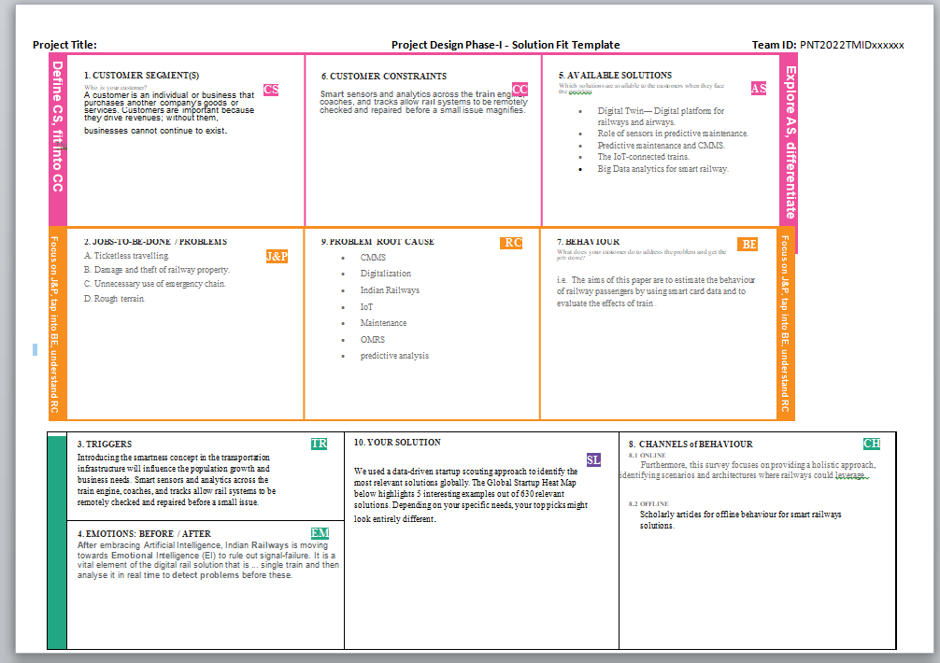

References:

1. <https://ieeexplore.ieee.org/document/8026132>
2. <https://ieeexplore.ieee.org/document/8026132>